**Configuration/Installation Manual**

**By Greg Bayne, Kari Franklin, and Michael Booser**

1. Download ZIP from github

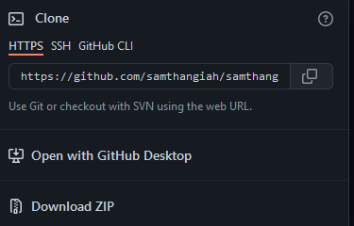

1. Text

   Description automatically generatedUnzip the project into desired location on user’s PC.
2. Text

   Description automatically generatedMove unzipped file into desired workspace.
3. Installing Eclipse IDE
   1. Installing Eclipse

* go to the link <https://www.eclipse.org/eclipseide/>
* click “Download 2022-03” in the top left of the page.
  1. Installing Eclipse 2022-03

This provides a guide for installing the most current version of eclipse IDE. In order to download is correctly follow these steps:

1. 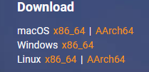Choose the version you want to download as illustrated.

1. Click “download”
2. Click “open file” when it’s done downloading
3. ****Click “Eclipse IDE for Java Developers”
4. Choose the installation Folder destination or go with the default
5. . You can choose whether to create a start menu entry as well as if you want to create a desktop shortcut.
6. Click “Install”

* Click “accept” for Eclipse Founder Software User Agreement.

1. Click “launch”
2. Graphical user interface, text

   Description automatically generatedIn the upper-lefthand corner, select “File” > “Open Projects from File System…”.
3. Graphical user interface, text, application, email

   Description automatically generatedOn the line that says input source, find and select “Directory…”.
4. A screenshot of a computer

   Description automatically generatedBrowse the file explorer to find: (workspace) > samthangiah-Spring-2022---Distance-and-Directions-with-Google-Maps-master. Select the folder.
5. Graphical user interface, text, application, email

   Description automatically generatedSelect both folders to import (Both boxes on left-hand side should be checked). Select “Finish”.
6. Eclipse will recognize the program. Please wait for files to populate and update.

**In the Package Explorer:**

1. Graphical user interface, text, application, chat or text message

   Description automatically generatedTraverse to: DistanceAndDirections/src/main/java/edu/sru/bayne/DistanceAndDirections/DistanceAndDirectionsApplication.java
2. Graphical user interface, application

   Description automatically generatedRight-click on “DistanceAndDirectionsApplication.java”. Select Run As > Java Application.

*Note*: When console displays message “Server is running on localhost:8080”, the site will be running and functional.

**In a Web Browser**

1. Graphical user interface, application

   Description automatically generatedEnter ‘localhost:8080’ into the search bar and hit enter to access the website.